**ANSWERS**

TASK 6 ATAR CHEMISTRY UNITS 1 & 2

RESEARCH ASSIGNMENT QUIZ 2

SHE 5 - Aqueous solutions and acidity

(TEST 3 Part A) (25 marks)

1. Chlorination is used to purify water and make it possible to drink.

Briefly explain why and how this process is carried out. (4 marks)

**Kills micro-biological organisms**  (1 Mark)

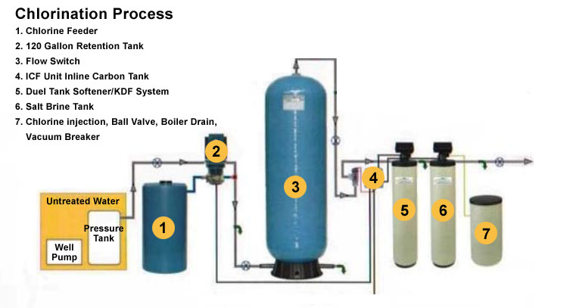

**Explaination of the process above**  (3 marks)

**Three points 1 mark each**

1. The diagram below shows one method that can be used to purify water.

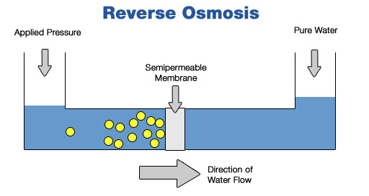

1. What is the name of the treatment process that uses this method?

**Desalination** (1 mark)

b) Explain the steps in this treatment process. (5 marks)

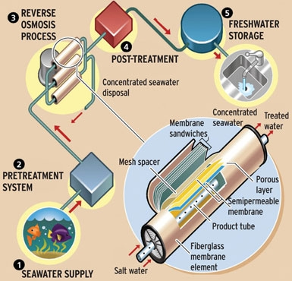

**Explain the steps shown above**

1. a) Give two examples of heavy metals often found in drinking water?

(2 marks)

**Nickel, Lead, Cadmium, Zinc**

**only two required and there are others**

1. What is an acceptable level of these heavy metals for the water to be

considered safe to drink? (3 marks)

**WHO Guidelines**

**nickel has been set at 0.02 mg/L**

**lead has been set at 0.01 mg/L**

**cadmium has been set at 0.003 mg/L**

**zinc has been set at 3 mg/L**

**(mercury 2 µg/litre not a main metal)**

**must match answer above values (2 marks)**

**units provided (1 mark)**

1. Briefly describe how they reduce these heavy metals and bring them

to an acceptable drinking level.

(2 marks)

**Any suitable method**

**there are some methods used explained below**

**Method 1**

**Reverse Osmosis can be performant at removing low level of heavy metals,although in aerobic conditions metal oxides can clog the membranes. Also, RO is not a very cost efficient method, unless the water salt content requires further demineralisation.**

**Method 2**

**Heavy metals can be removed from groundwater with the use of a selective ion exchange resin.**

**Method 3**

**Precipitation of toxic heavy metal salts as sulfides**

**Method 4**

**Cyclic electrowinning/precipitation (CEP) system, the process involves increasing the concentration of heavy metals in water samples, until it's high enough to be effectively removed.**

**Metal-tainted water is fed into a tank, and an acid or base (such as sodium hydroxide) is added to change the water's pH value. This causes the water molecules to separate from the heavy metal precipitate, which settles to the bottom of the tank. The clean water is then siphoned off, more tainted water is introduced, and its metal content joins that already lying at the bottom. The process is repeated a number of times.**

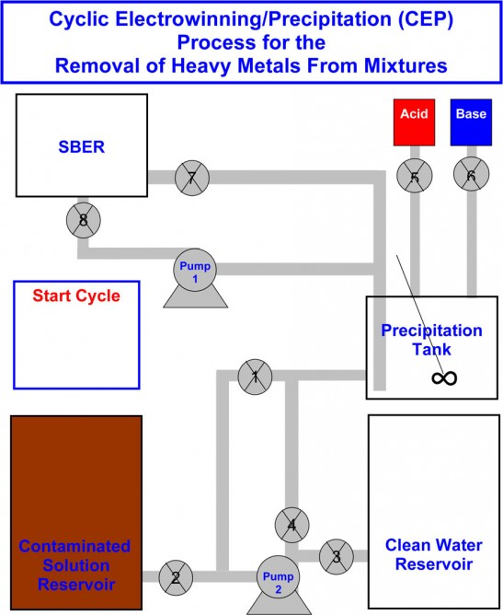**The settled precipitate forms into a toxic sludge, which is difficult to safely dispose of. That's where part two of CEP comes into play.**

**Once the sludge in the first tank has reached a high enough heavy metal concentration, it is pumped into a second device called a spouted particulate electrode. There, it is subjected to a process called electrowinning, in which an electrical current is used to transform the metal ions into a stable, solid, and thus easily-removed state. The water left over is then returned to the first tank, where most of the remaining metal content is settled out. That water then goes to another reservoir, where other processes are employed to further remove heavy metal ions.**

**Method 5**

**l-cysteine methyl ester - which has a similar structure to the naturally occurring amino acid cysteine – attached to the surfaces of minute glassy carbon spheres. Then the spheres are added to the water samples containing varying amounts of heavy metals, and stirred the mixtures.**

**When the glassy carbon spheres were removed the amount of toxic metal in the water was reduced significantly.**

**Method 6**

**Special absorbents are commercially available for the removal and retrieval of toxic heavy metal ions from waste water (using activated carbon, peat moss, brown coal and other cellulose materials are finding increasing application in wastewater treatment.**

1. How is this method influenced by social and economic factors?

(2 marks)

**Social - The selection of a treatment process depends not only on the nature of the primary wastes, but also on other factors including the national regulations and the standards concerning waste.**

**Economic -When wastes are unsuitable for disposal, a suitable method or combination of methods must be selected for pretreatment of the waste before safe disposal this can be costly.**

**Any suitable/logical answer**

4. a) Why is water fluorinated? (2 marks)

**Fluoride significantly (1 mark) reduces dental decay (1 mark)**

b) In what form is fluoride that is added to water in Australia?

Give name and formula (2 marks)

**NaF – sodium fluoride**

c) At what level is it added to our water? (2 marks)

**1 ppm** 1 mark for value

1 mark for units

END OF PART A